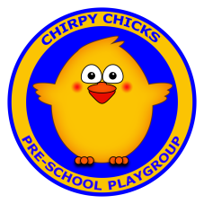 | Email - info@chirpychicksplaygroup.com  Website - www.chirpychicksplaygroup.com  Facebook - @chirpychicksplaygroup  Tel : 07577855185

Deputy Leader (Maternity Cover) - Application form
Continue details on a separate sheet/document if required and include with this form, or expand the text boxes if completing in WORD
Closing date for applications via post or email is Friday 6th November 2020 at 4pm.

Name :

Address :

Postcode : | Telephone :

Education and training : (Level 5 is required by the Minimum Standards)

Details and results of any examinations taken, including Further Education :

Any Present Employer : Address, Postcode, Job title, Duties :

Other Employment history (Include date employed, to/from) :

*No approach will be made to your present employer without informing the candidate in the first instance.

Please tell us about other jobs you have done and about the skills you used and/or learned in those jobs :

Please tell us why you applied for this position and why you think you are the best person for the job :

Do you consider yourself to have a disability? Yes No

Please tell us if there are any ‘reasonable adjustments’ we can make to assist you in your application or with our recruitment process :

I can confirm that to the best of my knowledge the above information is correct. I accept that providing deliberately false information could result in my dismissal should I be engaged in employment.

Signature : | Date :

This document can be emailed to info@chirpychicksplaygroup.com or if submitting by post send to :
Chirpy Chicks Playgroup Ltd, 10A Dunevly Road, Portaferry, Co.Down, BT22 1NB

Chirpy Chicks Playgroup Ltd is an equal opportunities employer
_____

Chirpy Chicks Playgroup is a not-for-profit social enterprise providing pre-school education and empowering children to take on the world with curiosity, confidence, and positivity.

